**SRM Institute of Science and Technology**

**College of Engineering and Technology**

**DEPARTMENT OF ECE**

SRM Nagar, Kattankulathur – 603203, Chengalpattu District, Tamilnadu

Academic Year: 2022-23 (Odd)

Assignment : II-Answer Key Date: 30/08/2022

Course Code & Title: 18ECC301T - Wireless Communication

Year & Sem: VII Max. Marks: 20

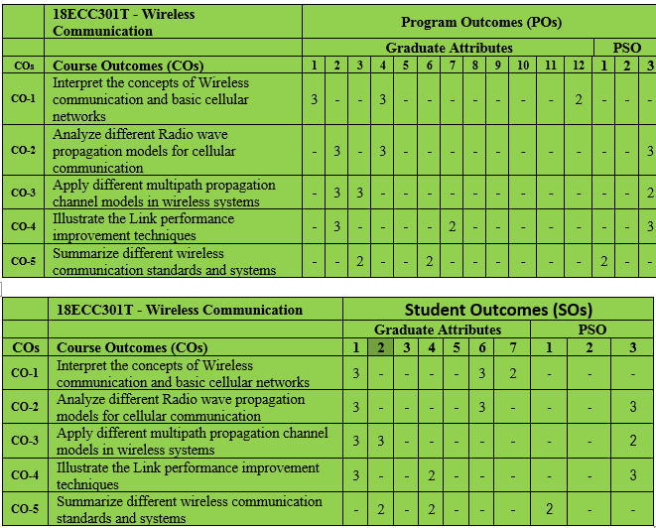

|  |  |  |  |  |  |
| --- | --- | --- | --- | --- | --- |
| **S No** | **Answer All Questions** | **Marks** | **CO** | **BL** | **PO** |
| 1 | i) A mobile is located 5 km away from the base station and uses a vertical λ/4 monopole antenna with a gain of 2.55 dB, to receive cellular signal. The E field at 1 km away from the transmitter is measured to be 10−3 v/m, the carrier frequency is 900 MHz.  A] Find the length and the effective aperture of the receiving antenna.  B] Find the received power at the mobile using 2 ray ground reflection model assuming height of 50 m and receiving antenna is 1.5m above the ground.    ii) Determine the propagation pathloss for a radio signal at 900 MHZ cellular system operating in a large urban city,with a base station Tx antenna height of 100m and mobile Rx antenna height of 2m.The mobile unit is located at a distance of 4 Km . Use the Hata propagation path loss model. | 5 marks  5 marks | 2 | 3 | 2  4 |
| 2 | i)Consider a base station transmitter operating at 900MHZ carrier frequency.For a mobile moving at a speed of 72 km/h,Calculate the received carrier frequency if the mobile is moving.  (a)directly away from the base station transmitter  (b) directly towards from the base station transmitter  (c) in a direction perpendicular to the direction of arrival of the transmitted signal.  (d) in a direction 60 degree to the direction of arrival of the transmitted signal.          ii) Measurement of a radio channel in the 800 MHZ frequency band indicate that the coherent bandwidth is approximatley 100 KHZ what is the maximum symbol rate that can bow transmitted over this channel that will suffer minimal ISI (Spreading of symbol<10% cause negligible ISI) | 8 marks | 3 | 4 | 3 |
|  | 2 marks |  |  | 2 |

**Course Outcome (CO) and Bloom’s level (BL) Coverage in Questions**

**Evaluation Sheet**

**Name of the Student: Register No.:**

|  |  |  |  |  |  |
| --- | --- | --- | --- | --- | --- |
| **Answer ALL questions** | | | | | |
| **Q. No** | **CO** | **PO** | **Maximum Marks** | **Marks Obtained** | **Total** |
| **1** | **CO2** | **PO2** | **5** |  |  |
| **2** | **CO2** | **PO4** | **5** |  |
| **3** | **CO3** | **PO2** | **2** |  |
| **4** | **CO3** | **PO3** | **8** |  |

**Consolidated Marks:**

|  |  |  |
| --- | --- | --- |
| **CO** | **Maximum Marks** | **Marks Obtained** |
| **2** | **10** |  |
| **3** | **10** |  |
| **Total** | **20** |  |

|  |  |  |
| --- | --- | --- |
| **PO** | **Maximum Marks** | **Marks Obtained** |
| **2** | **7** |  |
| **3** | **8** |  |
| **4** | **5** |  |
| **Total** | **20** |  |

**Signature of Course Teacher**